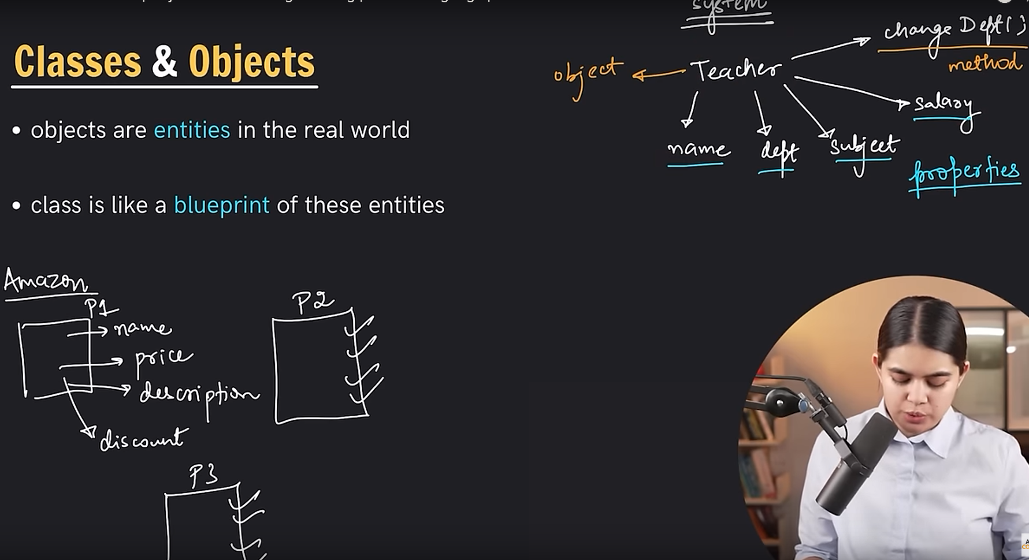

**Code:**

#include <bits/stdc++.h>

using namespace std;

class Employe{

//properties OR Attribute

private:

double salary;

public:

string name, dept, city;

void changedept(string depart){

dept = depart;

}

//setter

void setSalary(double newsalary){

salary = newsalary;

}

//getter

double getSalary(){

return salary;

}

};

int main()

{

Employe e1;

e1.name="Sayed Nahid";

e1.dept="CSE";

e1.city="Dhaka";

cout << e1.name << endl;

cout << e1.dept << endl;

e1.changedept("EEE");

cout << e1.dept << endl;

e1.setSalary(20000);

cout << e1.getSalary() << endl;

return 0;

}